Project Planning Phase

**Project Planning Template (Product Backlog, Sprint Planning, Stories, Story points)**

|  |  |
| --- | --- |
| Date | 18 October 2022 |
| Team ID | PNT2022TMID05007 |
| Project Name | Project – Plasma Donor Application |
| Maximum Marks | 8 Marks |

Product Backlog, Sprint Schedule, and Estimation (4 Marks)

Use the below template to create product backlog and sprint schedule

|  |  |  |  |  |  |  |
| --- | --- | --- | --- | --- | --- | --- |
| **Sprint** | **Functional Requirement (Epic)** | **User Story Number** | **User Story / Task** | **Story Points** | **Priority** | **Team Members** |
| Sprint-1 | Donor Registration | USN-1 | As a user, I can register in the donor application by entering my name, phone_no,  Email id, blood group ,aadhar no | 9 | High | Team Lead (M.Priyadharshini) |
| Sprint-1 | Login | USN-2 | As a admin, I can log into the application by entering email & password | 9 | High | Team Lead |
| Sprint-1 | Chatbot | USN-3 | As a user I can ask query in chatbot. | 2 | Medium | Team Lead |
| Sprint -2 | Confimation | USN-4 | As a user, I can receive confirmation mail. | 4 | Medium | Team Lead |
| Sprint - 2 | Dashboard | USN-5 | As a user, I can view dashboard and select | 5 | Medium | Team Member 1 |
| Sprint-2 | View Donor List | USN-6 | As a user, I can view all the donor list and contact them directly | 9 | High | Team Lead |
| Sprint-2 | Search Donor | USN-7 | As a user, I can search for the donor | 9 | Medium | Team Lead |
| Sprint-3 | About us | USN-8 | As a User, I can view the about us page which contains all contact information | 5 | Medium | Team Member 2 |

|  |  |  |  |  |  |  |
| --- | --- | --- | --- | --- | --- | --- |
| **Sprint** | **Functional**  **Requirement (Epic)** | **User Story**  **Number** | **User Story / Task** | **Story Points** | **Priority** | **Team Members** |
| Sprint-3 | Modify data | USN-9 | As a admin, I can modify the User data. | 9 | High | Team Lead |
| Sprint-3 | Send mail | USN-10 | As a user, I can send mail to donors using sendgrid. | 9 | High | Team Lead Team Member 3  Team Member 1 |
| Sprint-3 | Home page | USN-11 | As a user I can view the home page and select the desired option. | 9 | Medium | Team Lead Team Member 1  Team Member 2  Team Member 3 |
| Sprint -4 | Send Query | USN-12 | As a user I can ask my query through email. | 9 | Medium | Team Lead Team Member 3 |
| Sprint-4 | Download data | USN-13 | As a admin I can download the user data | 9 | High | Team Lead |

Project Tracker, Velocity & Burndown Chart: (4 Marks)

|  |  |  |  |  |  |  |
| --- | --- | --- | --- | --- | --- | --- |
| **Sprint** | **Total Story Points** | **Duration** | **Sprint Start Date** | **Sprint End Date (Planned)** | **Story Points Completed (as on**  **Planned End Date)** | **Sprint Release Date (Actual)** |
| Sprint-1 | 20 | 6 Days | 24 Oct 2022 | 29 Oct 2022 | 20 | 29 Oct 2022 |
| Sprint-2 | 20 | 6 Days | 31 Oct 2022 | 05 Nov 2022 | 20 | 5 Nov 2022 |
| Sprint-3 | 20 | 6 Days | 07 Nov 2022 | 12 Nov 2022 | 20 | 12 Nov 2022 |
| Sprint-4 | 20 | 6 Days | 14 Nov 2022 | 19 Nov 2022 | 20 | 19 Nov 2022 |

Velocity:

Imagine we have a 10-day sprint duration, and the velocity of the team is 20 (points per sprint). Let’s calculate the team’s average velocity (AV) per iteration unit (story points per day)



Velocity:

AV=20/6=3..333…

Sprint 1(AV)= 3.34

Sprint 2(AV)= 3.34

Sprint 3(AV)= 3.34

Sprint 4(AV)= 3.34

Burndown Chart:

A burn down chart is a graphical representation of work left to do versus time. It is often used in agile [software development](https://www.visual-paradigm.com/scrum/what-is-agile-software-development/) methodologies such as [Scrum](https://www.visual-paradigm.com/scrum/scrum-in-3-minutes/). However, burn down charts can be applied to any project containing measurable progress over time.

<https://www.visual-paradigm.com/scrum/scrum-burndown-chart/>

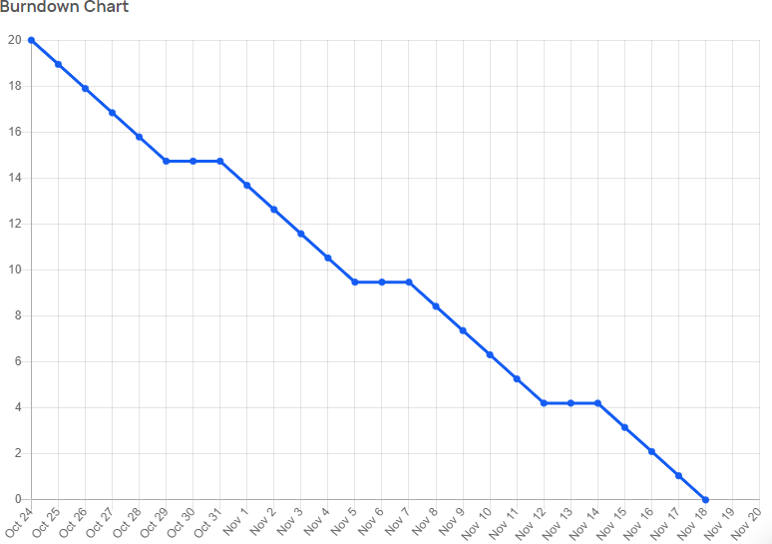

<https://www.atlassian.com/agile/tutorials/burndown-charts>

Reference:

<https://www.atlassian.com/agile/project-management> <https://www.atlassian.com/agile/tutorials/how-to-do-scrum-with-jira-software> <https://www.atlassian.com/agile/tutorials/epics> <https://www.atlassian.com/agile/tutorials/sprints> <https://www.atlassian.com/agile/project-management/estimation> <https://www.atlassian.com/agile/tutorials/burndown-charts>